SpotCheckAI: An Analysis Tool for Suspicious Skin Lesions Utilizing Image Recognition

Rafferty Leung#1, Henry Wong#2

# Seidenberg School of Computer Science and Information Systems, Pace University  
1 Pace Plaza, New York, NY 10038, USA

1rafferty.leung@pace.edu

2hwong@pace.edu

Abstract— Patients requiring time-sensitive treatment for dermatological illnesses may face life-threatening consequences due to the prolonged wait times for dermatology appointments. SpotCheckAI is a web application that employs machine learning for self-diagnosis and triaging in dermatology. The application consists use of the ResNet-50 convolutional neural network (CNN) model for image classification and the use of OpenAI’s GPT to power the application’s chatbot. This paper presents a literature review of some current technologies on the market, their advantages, shortcomings, and why there is a need for more open-source technologies such as SpotCheckAI. SpotCheckAI is a free and accessible application that provides a potential solution for physicians and patients. By providing a user-friendly platform for self-diagnosis and triaging in dermatology, SpotCheckAI offers an accessible and efficient way for patients to address their dermatological needs promptly, potentially preventing life-threatening consequences.

Keywords— web development, dermatology, melanoma, image classification, machine learning, neural networks, deep learning, OpenAI, ChatGPT, GPT-3, ResNet-50

1. Introduction

SpotCheckAI is an self-diagnosis application that arose in an effort to help potentially streamline the physician workflow in triaging patents and scheduling patient appointments. Across all sub-specialities, the average wait time for an appointment with a physician is 26 days. [9] For patients with time-sensitive matters, waiting that length of time could result in more prolonged and complicated treatment plan.

SpotCheckAI is a progressive web application (PWA) that serves a dual purpose of providing preliminary analysis to patients and triaging patients when seeing a dermatologist. The application comprises of two major components - a client-side user interface and a machine-learning model for image classification. The model utilized by SpotCheckAI is a ResNet-50 convolutional neural network (CNN) that attempts to accurately classify image inputs from the client-side user interface. Moreover, in addition to the CNN model, SpotCheckAI also incorporates the use of GPT models developed by OpenAI to power its chatbot functionality, providing a comprehensive and advanced experience to its users.

1. Literature Review

This section can be divided into four distinct parts, which feature an analysis of four organizations that offer comparable tools in the market along with their current methodologies.

1. SkinVision

SkinVision is a subscription-based mobile app that uses artificial intelligence to analyze photos of skin lesions and provide users with an instant risk assessment of whether the lesion appears to be benign or potentially cancerous. Users can take photos of their skin using the app and receive a risk assessment within 30 seconds. [10] SkinVision has tiered subscription services and is currently only available in the European Union.

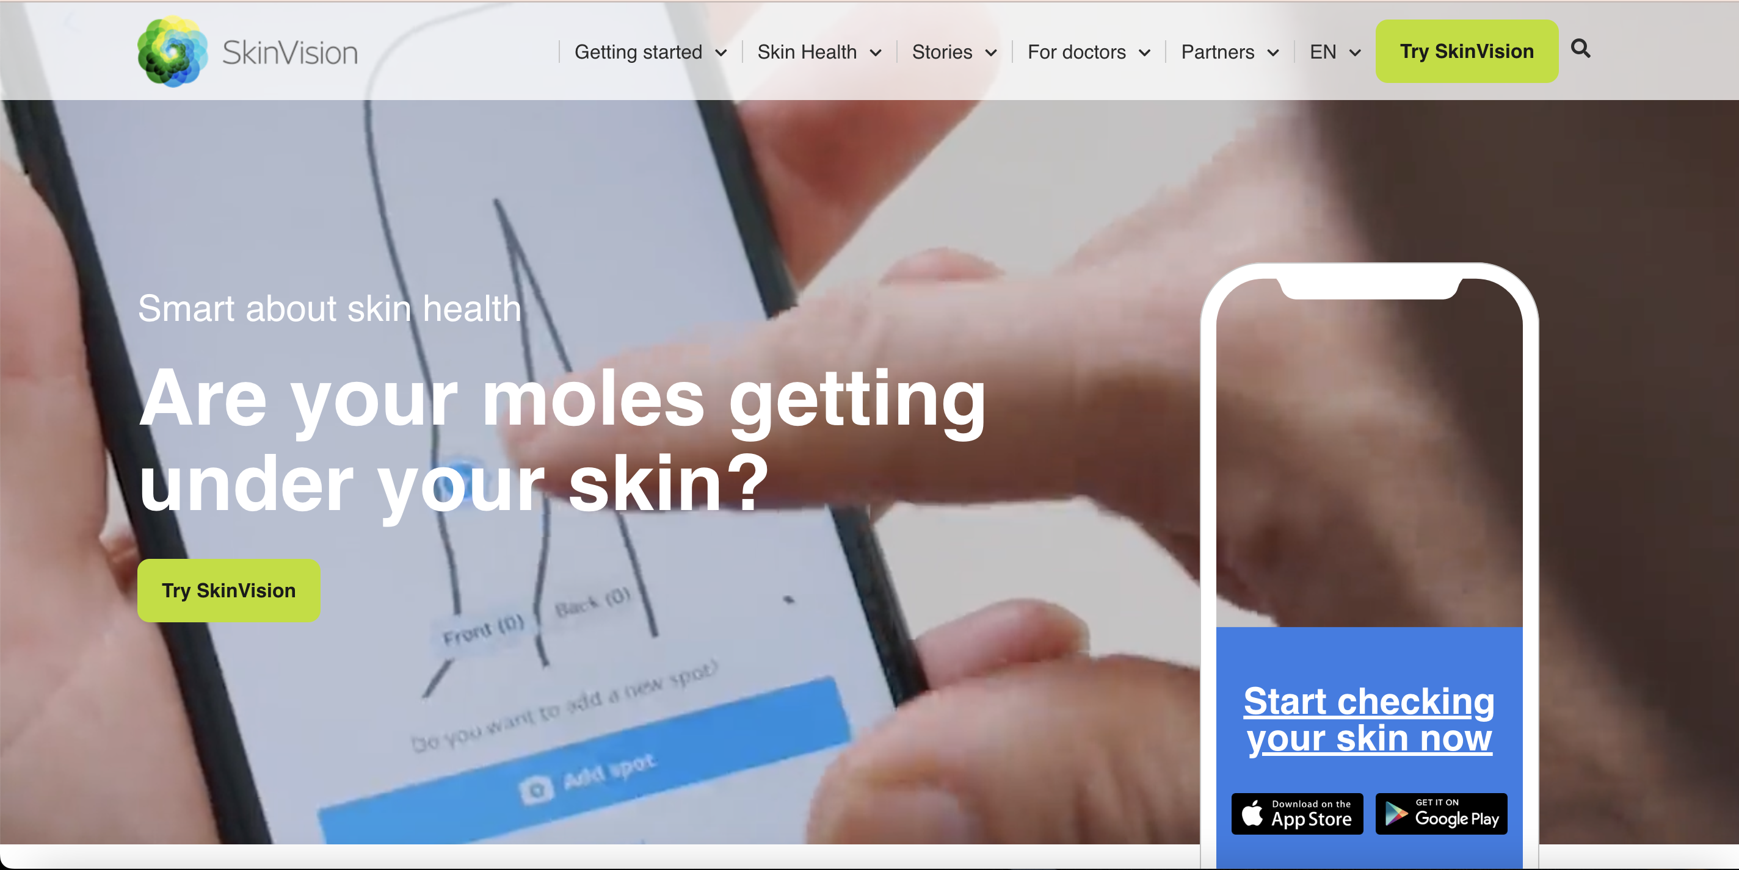

Fig 1. Screenshot of the SkinVision Webpage. [10]

1. SkinScan

SkinScan is a mobile application designed to assist in the early detection of skin cancer. The app uses artificial intelligence and machine learning algorithms to analyze images of skin lesions and moles for signs of potential skin cancer. Users take a photo of their skin lesion or mole with a smartphone camera and upload it to the SkinScan platform. The app analyzes the image and provides a risk assessment of the lesion, indicating whether it is low, medium, or high risk for skin cancer. [12] SkinScan is also only available in the European Union.

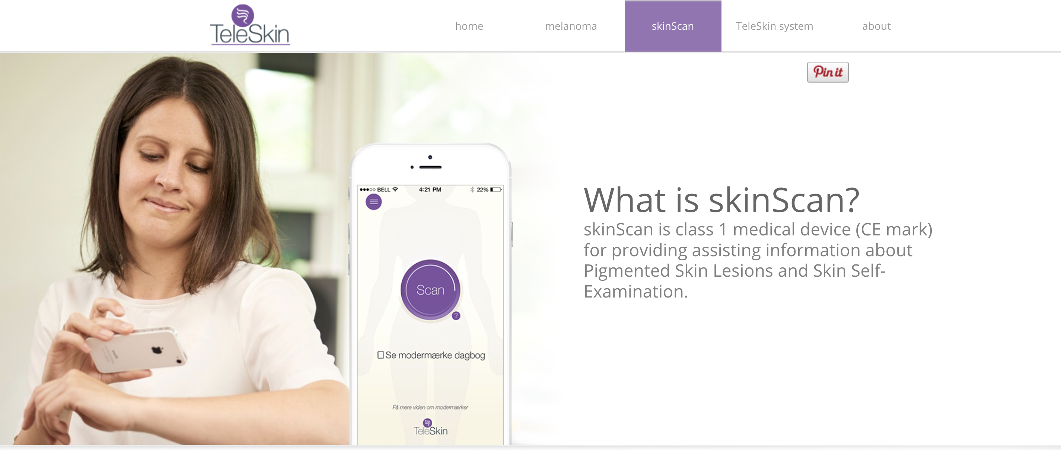

Fig 2. Screenshot of the SkinScan Webpage. [12]

1. UMSkinCheck

UMSkinCheck is a free mobile app developed by the University of Michigan that allows users to perform skin self-examinations and receive instant risk assessments for potential skin cancer. The app guides users through the self-examination process, providing step-by-step instructions on how to take photos of their skin and identifying the areas to focus on. The photos are then analyzed by the app using artificial intelligence and machine learning algorithms to provide an instant risk assessment of the lesions. [15]

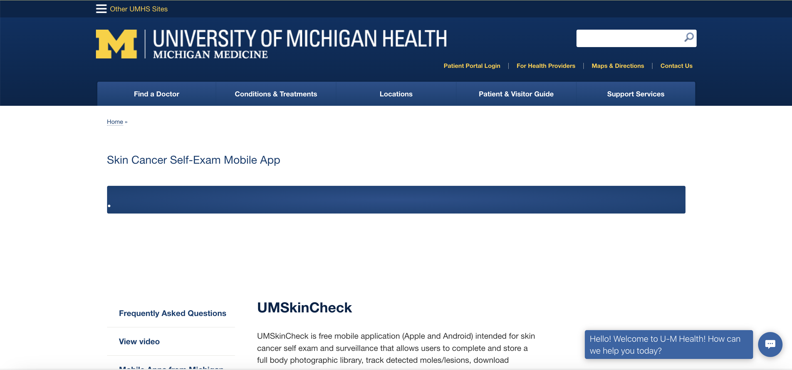

Fig 3. Screenshot of the UMSkinCheck webpage. [15]

1. DermAssist

DermAssist is a skin health tool developed by Google Health that uses artificial intelligence to assist users in identifying common skin conditions. The tool allows users to take three photos of the affected area from different angles using their smartphone camera, and then analyzes the photos using machine learning algorithms to provide an instant assessment of the most likely skin condition. [5] DermAssist provides users with information on the condition, including common causes and treatments, and offers suggestions for when to seek medical attention.

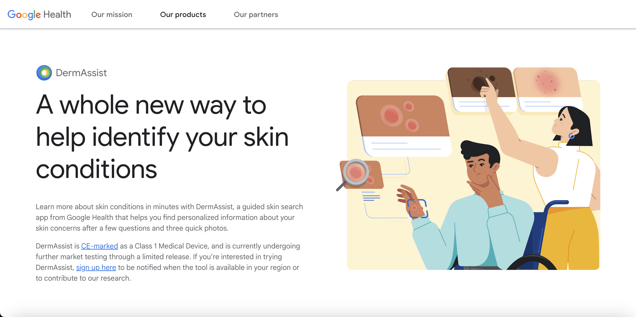

Fig 4. Screenshot of the DermAssist webpage. [4]

1. Evaluation and Analysis

A self-diagnostic application is designed to assist individuals in identifying their illness based on their reported symptoms. However, it's important to note that such applications are not completely reliable as they rely on algorithms and previously documented datasets rather than the expertise of a trained medical professional. The purpose of diagnostic applications is to complement a physician’s practice and help streamline their patient workflow more efficiently.

In principle, self-diagnostic applications already exist with the explosion in popularity in WebMD and optimized search engines. Users currently can look up potential diseases, treatments, and outcomes based on their symptoms. Users typically will then take this synthesized information with them to their physician’s office to gain further understanding and a confirmed diagnosis.

Diagnostic applications have become increasingly popular in recent years, with many users relying on them to help identify potential health concerns based on their symptoms. [1] However, these apps often come with limitations and drawbacks. Moreover, some apps may incorporate advertisements which may draw away from the purpose of providing accurate medical advice.

Here, we analyze and identify the shortcomings of current applications on the market in order to better understand their limitations and improve their functionality. Table 1 displays a high-level functionality overview of four applications on the market.

TABLE I  
An overview of four skin lesion diagnosis applications

|  |  |  |  |
| --- | --- | --- | --- |
| **Application Name** | **Platform** | **Subscription Required** | **Available for Public Use** |
| SkinVision | Mobile Application | Yes | EU Only |
| SkinScan | Mobile Application | Yes | EU Only |
| UMSkinCheck | Mobile Application | No | Yes |
| DermAssist | Mobile Application | Unknown | Authorized Physicians Only |

For the purposes of analysis, SkinVision and SkinScan (“paid mobile applications”) will be compared together as they both employ similar methodologies.

The paid mobile applications use a subscription model where users pay, upload, and display a degree of certainty that a lesion is cancerous or benign. No public information was available about the machine learning model or algorithms employed. Furthermore, benchmarking criterion listed on the companies’ respective websites are questionable due to study and sample size. [5] Some other issues noted were: small sample size, photos that did not meet evaluation criteria were excluded, no follow up for study participants to see if cancers were identified by physicians but missed by apps. [11] In addition, peer reviewed journals for these two applications noted poor accuracy. [5]

UMSkinCheck’s benchmarking is unknown however, it is available for download in the Android and Apple App Store. The University of Michigan released the application back in 2012. At the time of writing, based on user reviews, the application appears to be defunct. [13] In addition, based off of the version history in the Apple App Store, the machine learning model used in this application has not been updated since application inception. Only small updates were made to the user interface and for compatibility with devices and operating systems. [14]

DermAssist is Google’s version of a skin lesion classifier. It is not publicly available and little information is known about the application other than users can upload three photos and the program will output the proposed skin condition. DermAssist can identify 90% of commonly searched skin conditions. Other benchmarks regarding DermAssist are unknown. [5]

The four presented applications have similar functionalities where they receive an input and utilizing its internal algorithms, a prediction is made. All options presented are absent of a holistic peer review, namely, missing peer reviewed material regarding the algorithms deployed. The focus has been on benchmarks rather than methodologies. There is a significant need for more open-source and freely available tools such that better detection algorithms can be employed.

The four applications presented employ similar core functionalities. They all take an input and apply internal algorithms to predict the output. However, none of the presented options have undergone peer review regarding itself algorithms but rather their overall benchmarks. This raises concerns regarding efficacy and reliability of the algorithms implemented in these applications.

It is imperative that we invest more in the development of open-source and freely available tools. Such resources will enable us to create better detection algorithms that can tackle broader issues. These tools will allow for a more transparent and collaborative approach to research and development, which can lead to better results and greater confidence in the algorithms used.

The absence of peer reviews in these applications does not necessarily mean that the algorithms and internal methodologies employed are not effective predictors. However, the absence of such a process leaves room for doubt which can potentially have significant ramifications.

Therefore, it is crucial that open-source and freely available tools are available and subject to peer reviews that makes remarks on algorithm use and benchmarks.

1. Methodology

SpotCheckAI has been designed as a web application with the aim of predicting suspicious lesions, streamlining physician's practices, and ensuring transparency in the machine learning model's usage and level of confidence. Its feature implementation consists of a frontend user interface and a backend interface, which includes the machine learning model. The technologies utilized in SpotCheckAI include:

1. *Front End* – The client-side of SpotCheckAI uses HTML, CSS, JavaScript, Ionic, and React. This enables use of the website with seamless responsive user interface integration across any device with browser access.
2. *Back End* – The server-side of SpotCheckAI is a REST API implemented using Django and Django REST framework to send RESTful requests and receive RESTful responses on the client-side. The machine learning algorithm was implemented using the Keras Library with TensorFlow as the backend engine. The chatbot was implemented using web scraping, embeddings, and OpenAI’s API. It is also available as a REST API on Django.

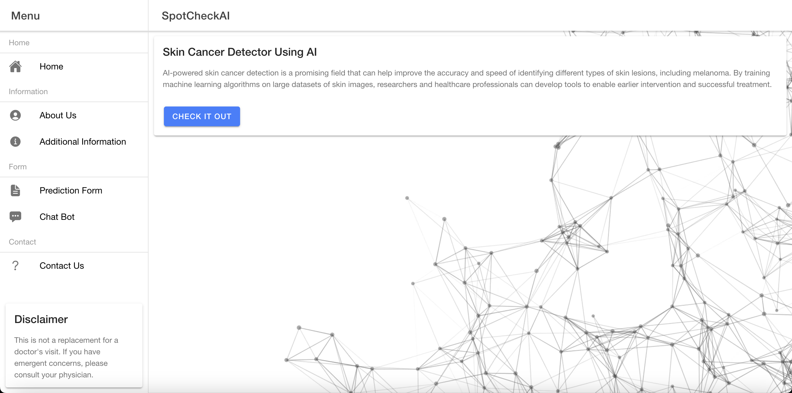

Fig 5. Homepage of SpotCheckAI.

*A. Django*

Django is a robust web-framework written in Python and has gained popularity among developers for its ability to facilitate rapid development of server-side web applications, making it a preferred choice for building complex web projects. [2]

Django was selected for use due to its robustness, large user community, ease of use with third-party packages, and maturity in the market.

*B. Django REST Framework*

Django REST Framework (DRF) is a toolkit used to build Web APIs. RF provides a set of reusable tools and building blocks that make it easy to create APIs that can handle complex data types, authentication, and permissions. It supports view sets and routers for defining Create, Read, Update, Delete (CRUD) operations, and has built-in support for authentication methods. DRF simplifies the process of building Web APIs by utilizing Django. [3]

DRF was selected to build the REST API because of its authentication methods. It provides secure access control to the machine learning model, ensuring that only authorized users can access it. Additionally, it offers secure data protection for the uploaded images, ensuring the confidentiality and privacy of user data.

*C. Keras and TensorFlow*

Keras and TensorFlow are open-source libraries used for building and training machine learning models. TensorFlow provides low-level APIs whereas Keras provides high-level neural network APIs. Keras simplifies the process of building and training machine learning models. [7]

*D. Image Classification*

The decision to utilize a CNN for image classification was made due to its proven ability to handle such tasks with great accuracy and effectiveness. A CNN has specialized architecture and abilities to automatically learn and extract relevant features from images. [8]

In this application, the CNN of use was ResNet-50. ResNet-50 is an architecture with 50 layers that incorporates multiple repetitions of convolutional layers, batch normalization layers, ReLU activation layers, and max pooling layers. ResNet-50 has been shown to be highly effective in image classification tasks. [6]

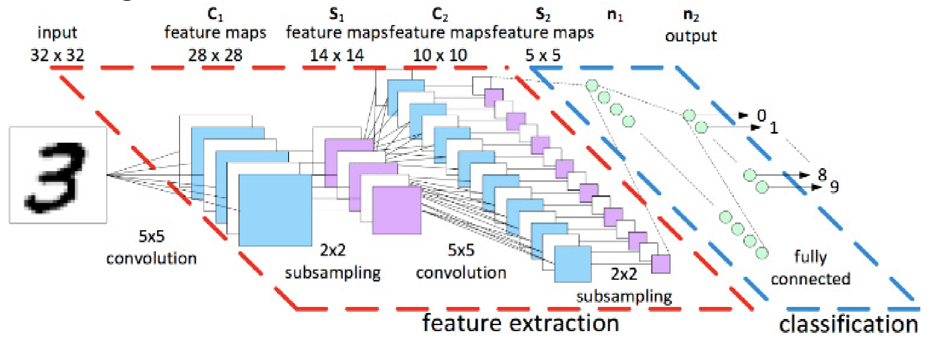

Fig 6. Representation of generic CNN layers. [8]

*E. ChatBot*

The chatbot was created by leveraging OpenAI's API and utilizing web scraping techniques on the front-end webpage. The chatbot's responses are based on scraped embeddings that serve as the foundation and index.

1. Results

The chatbot's performance was evaluated in terms of its ability to respond dynamically to user questions and provide relevant information about the website and its results. In a user test with questions regarding different aspects of the website, the chatbot was about to respond to the queries with 100% successfully. When users submitted irrelevant queries, the chatbot responded with the message "I don't know," indicating its inability to provide a relevant response. These results indicate that the chatbot is highly effective in responding to user queries related to the website and its results. Its ability to handle a wide range of user queries and provide accurate and timely responses makes it an invaluable tool for improving the user experience and customer service on the website.

The ResNet-50 model was evaluated for its ability to predict whether a lesion is cancerous or not. The model demonstrated an accuracy rate of 77%, indicating its effectiveness in identifying cancerous lesions. Although it is possible to improve the model's accuracy further through parameter tuning and by increasing input size and variation, the achieved accuracy rate of 77% is a promising starting point for a machine learning algorithm designed to predict cancerous lesions.

1. Conclusion

The popularity of machine learning and artificial intelligence in healthcare has opened new opportunities, but their reliability is not fully established. More testing and dataset generation are necessary to improve their accuracy. These applications are currently designed to complement physician practices and improve patient workflow.

However, self-diagnostic applications and optimized web searches may not be reliable for patients with ultra-rare conditions, as finding information may be challenging, and technical scientific papers may be required.

Despite these limitations, with advancements and improved accuracy, self-diagnostic applications have the potential to diagnose patients more efficiently. SpotCheckAI is a user-friendly, web-based application that provides preliminary analysis and triage for patients visiting dermatologists. It uses machine learning for image classification and integrates GPT models for its chatbot functionality. Other similar applications have been evaluated to improve their performance, but SpotCheckAI offers a promising future for healthcare technology by potentially enhancing the accuracy and efficiency of dermatological diagnosis and treatment.

References

[1] A. De, A. Sarda, S. Gupta, and S. Das, “Use of Artificial Intelligence in Dermatology,” *Indian J. Dermatol*., vol. 65, no. 5, pp. 352–357, 2020, doi: 10.4103/ijd.IJD_418_20.

[2] “Django,” *Django Project*. <https://www.djangoproject.com/> (accessed Feb. 22, 2023).

[3] “Home - Django REST framework.” <https://www.django-rest-framework.org/> (accessed Feb. 22, 2023).

[4] “Identify Skin Conditions with DermAssist – Google Health.” <https://health.google/consumers/dermassist/> (accessed Feb. 21, 2023).

[5] K. Freeman et al., “Algorithm based smartphone apps to assess risk of skin cancer in adults: systematic review of diagnostic accuracy studies,” *BMJ*, vol. 368, p. m127, Feb. 2020, doi: 10.1136/bmj.m127.

[6] K. He, X. Zhang, S. Ren, and J. Sun, “Deep Residual Learning for Image Recognition.” *arXiv*, Dec. 10, 2015. doi: 10.48550/arXiv.1512.03385.

[7] K. Team, “Keras documentation: About Keras.” <https://keras.io/about/> (accessed Feb. 22, 2023).

[8] N. Sharma, V. Jain, and A. Mishra, “An Analysis Of Convolutional Neural Networks For Image Classification,” *Procedia Comput. Sci*., vol. 132, pp. 377–384, Jan. 2018, doi: 10.1016/j.procs.2018.05.198.

[9] PatientEngagementHIT, “Average Patient Appointment Wait Time Is 26 Days in 2022,” PatientEngagementHIT, Sep. 15, 2022. <https://patientengagementhit.com/news/average-patient-appointment-wait-time-is-26-days-in-2022> (accessed Feb. 21, 2023).

[10] “SkinVision | Skin Cancer Melanoma Detection App,” Feb. 24, 2021. <https://www.skinvision.com/> (accessed Feb. 21, 2023).

[11] “Some smartphone apps not accurate enough to spot all skin cancers.” <https://www.bmj.com/company/newsroom/smartphone-apps-not-accurate-enough-to-spot-all-skin-cancers/> (accessed Feb. 21, 2023).

[12] T. Doo, “TeleSkin advanced dermoscopy platform and mobile app for early detection of skin cancer and melanoma,” TeleSkin - high-tech, venture backed startup. <https://teleskin.org/skinscan.html> (accessed Feb. 21, 2023).

[13] “UMSkinCheck - Apps on Google Play.” <https://play.google.com/store/apps/details?id=edu.umich.MySkinCheck&hl=en_US&gl=US> (accessed Feb. 21, 2023).

[14] “‎UMSkinCheck,” App Store, Oct. 03, 2017. <https://apps.apple.com/us/app/umskincheck/id522498604> (accessed Feb. 21, 2023).

[15] “UMSkinCheck | Michigan Medicine.” <https://www.uofmhealth.org/patient%20and%20visitor%20guide/my-skin-check-app> (accessed Feb. 21, 2023).